CIRCUIT DIAGRAM:

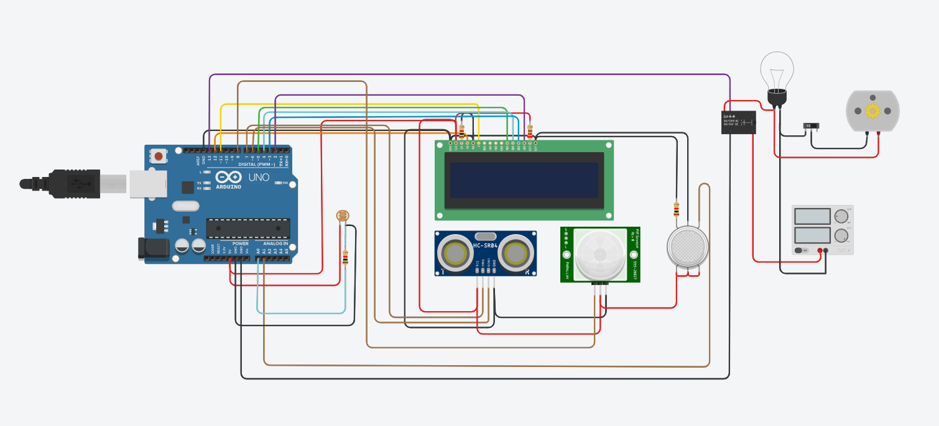

TINKERCAD LINK:

<https://www.tinkercad.com/things/3IHIF5g397V>